
OPERATOR AND BRANCH REFERENCE
Work Order Entry
User Guide
Document version 6 | 28 July 2026
Applies to the unified Work Order Entry_V4 executable
Purpose
This guide covers daily Work Order and Sales Quotation tasks, barcode-assisted item lookup, branch queue behavior, recall, cancellation, printing, and operator troubleshooting.

Document control
Field | Value
Document | Work Order Entry User Guide
Guide version | 6
Application | Work Order Entry_V4.exe (legacy executable name)
Audience | Order takers, supervisors, branch administrators, and support staff
Status | Current guide for the unified July 2026 branch-configurable build
Owner | SPU Development Team

What changed in this revision
- Removed unrelated check-processing instructions and error messages.
- Added database selection and login guidance.
- Documented Work Order versus Sales Quotation inventory and queue behavior.
- Added customer-change price confirmation and tax handling.
- Added branch queue settings, recall ownership, update locking, cancellation, and draft recovery.
- Added password-protected branch selection and assigned-database settings.
- Combined Work Order and Quotation printing into one automatic Order Number option.
- Clarified that changed-customer prices are confirmed by double-clicking each affected line.
- Added current shortcuts, troubleshooting, deployment prerequisites, and security cautions.
- Separated the guide version from the executable's legacy V4 filename.

Contents
1. Purpose and scope
2. Before you begin
3. Open the application and sign in
4. Main screen
5. Create a Work Order or Sales Quotation
6. Recall, update, convert, or cancel
7. Branch processing modes
8. Queue processing and For Invoicing
9. Draft recovery
10. Printing
11. Keyboard shortcuts
12. Troubleshooting
13. Support and escalation
Appendix A. Authorized deployment checklist
Appendix B. Current operational limitations
Use Word's Navigation Pane to jump between heading sections.

1. Purpose and scope
Work Order Entry is a VB.NET add-in used with Microsoft Dynamics RMS Store Operations. It creates and maintains Work Orders and Sales Quotations, supports barcode-assisted item lookup, applies customer pricing and tax rules, optionally reserves inventory, and can integrate with the branch processing queue.
Important distinction
A Work Order is type 2 and may reserve inventory. A Sales Quotation is type 3 and must not reserve inventory or create processing queue items. Both retain a queue header used for recall ownership.

1.1 Roles
Role | Typical responsibilities
Order taker | Create, price, save, recall, update, and print orders or quotations.
Supervisor | Approve restricted price or tax actions according to branch policy.
Branch administrator | Select the correct database and configure authorized branch functions.
Database administrator | Back up databases, run approved migrations, and validate stored procedures.

2. Before you begin
- Confirm that the workstation is connected to the correct branch network.
- Confirm the selected SQL Server and RMS store database before entering an order.
- Use only your assigned Work Order Entry username and password.
- Do not place database passwords in screenshots, email, or support tickets.
- If branch queue processing is enabled, confirm that queue compatibility tables have been deployed.
Production caution
Do not run migration scripts or repair live order, tax, queue, or inventory records without a verified database backup and authorization from the database owner.

3. Open the application and sign in
- Open RMS Manager.
- Select Utilities > Add-Ins > Work Order Entry, or use the approved desktop shortcut.
- If the store-selection screen appears, choose the authorized branch server and RMS database.
- If branch selection is locked, confirm that startup accepts the assigned RMS database. Stop if a Branch Database Mismatch message appears.
- Enter your Work Order Entry username and password.
- Verify the server and database shown in the application footer before continuing.
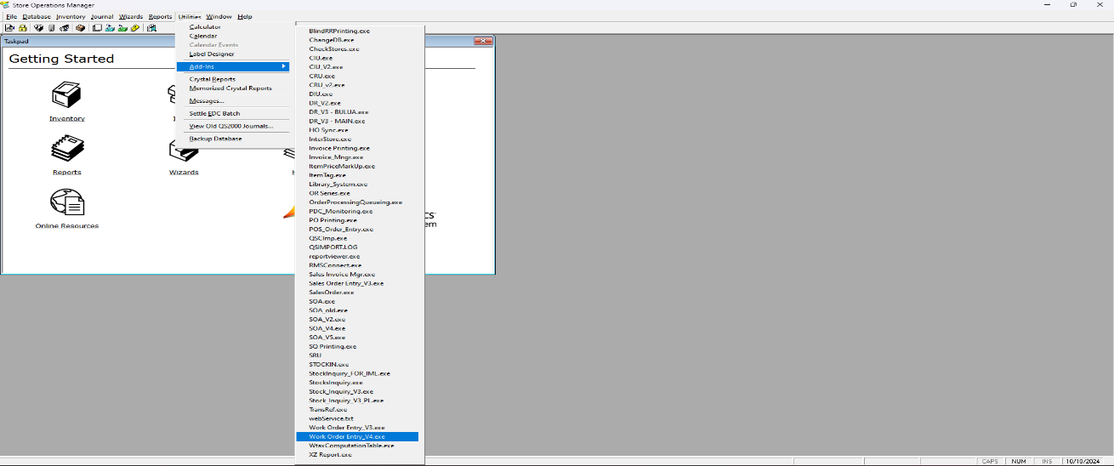
Figure 1. Launching Work Order Entry from RMS Manager.
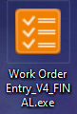
Figure 2. Approved desktop shortcut.
Login failure
If the selected database cannot be opened, stop and verify the server, database, network, and credentials. Do not continue in a different store database merely to bypass the error.

4. Main screen
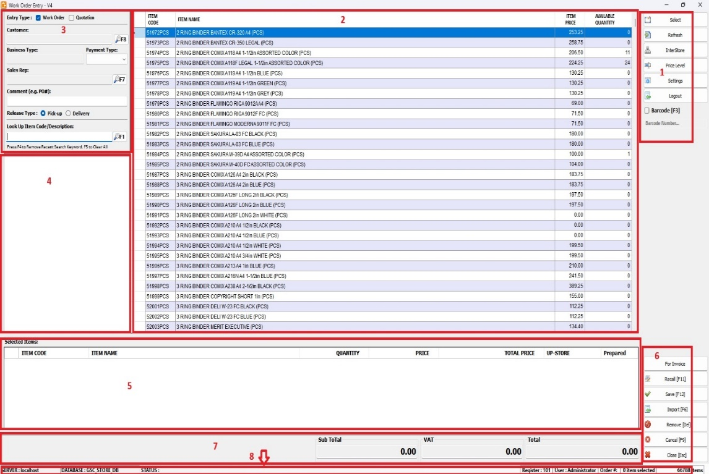
Figure 3. Main Work Order Entry screen. Controls may vary by branch settings.
Area | Use
Action buttons | Save, recall, import, print, settings, and close actions available to the user.
Item search | Search by item lookup code, description, or scanned barcode.
Search results | Displays matching RMS items and availability.
Selected-items grid | Displays quantity, confirmed price, tax state, totals, and pick location.
Customer/order panel | Order type, customer, sales representative, business/payment type, comments, and release type.
Totals | Subtotal, VAT, and total calculated from confirmed line values.
Footer | Current server, database, and signed-in user information.

Branch-dependent controls
Import and For Invoicing buttons may be hidden. Queue grouping is available only when it is enabled in Branch Functions.

5. Create a Work Order or Sales Quotation

5.1 Choose the order type
Choose the type before adding or saving items:
- Work Order: use when the customer order will proceed through fulfillment and POS.
- Sales Quotation: use for price canvassing or customer approval before fulfillment.
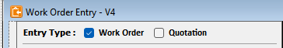
Figure 4. Order-type selector.

5.2 Select a customer
- Press F8 or select the Customer action.
- Search for and select the correct customer.
- Confirm the company name, business type, price level, tax status, credit information, and sales representative.
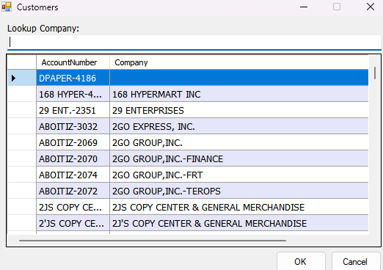
Figure 5. Customer selection list.
Changing a customer after items were added
Every selected line is highlighted and its price is replaced with a dash. The message shows how many lines require confirmation. Double-click each affected line and choose its authorized price. After one price is confirmed, the selection advances to the next unconfirmed line. The order cannot be saved until all prices are confirmed.

Screenshot placeholder
Insert a screenshot showing the multiple-item Price Confirmation Required message and highlighted unconfirmed lines.

5.3 Complete order information
- Sales representative: press F7 when manual selection is permitted.
- Payment type: select the customer-agreed payment method.
- Comment: enter a useful operational note; do not enter passwords or sensitive credentials.
- Release type: select Pick-up or Delivery.
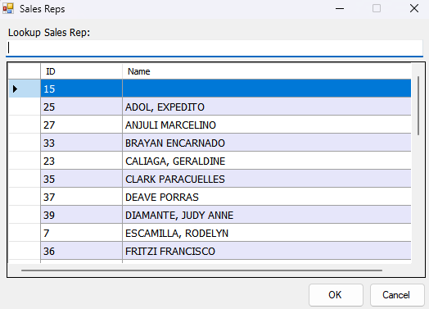
Figure 6. Sales representative selection.
Figure 7. Release-type selector.

5.4 Find an item or scan a barcode
- Place the cursor in the item-search field.
- Scan the barcode or enter an item lookup code or description.
- Press F1 when required to refresh the result list.
- Confirm the item code and description before selecting it.
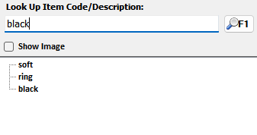
Figure 8. Item search results.
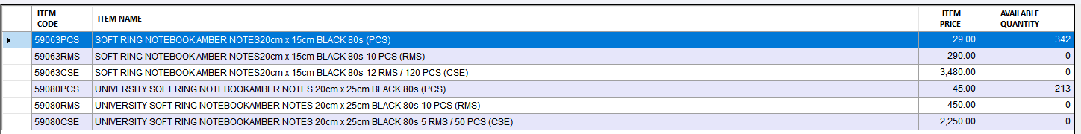
Figure 9. Filtered item list.
Barcode not found
Verify that the cursor is in the search field and scan again. If no exact RMS item lookup code is returned, search by description and report the barcode mapping to the item master-data owner.

5.5 Confirm price and add the item
- Double-click the item result or use the configured selection action.
- Review the available price levels. The customer's configured level is selected by default.
- Choose the authorized price and confirm the selection.
- Verify that the item appears in the selected-items grid.
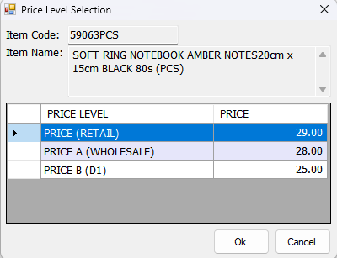
Figure 10. Price-level selection.
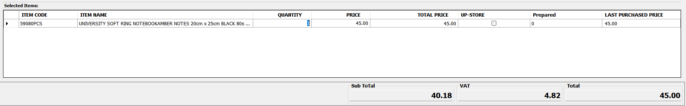
Figure 11. Item added to the selected-items grid.

5.6 Enter quantity and review totals
- Enter the required quantity. Fractional quantities are allowed when the RMS item and branch database support them.
- Review price, taxability, extended amount, subtotal, VAT, and total.
- Repeat item search and selection for additional lines.
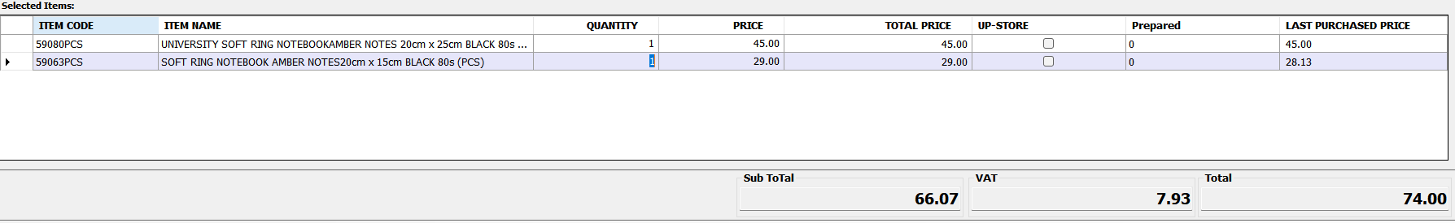
Figure 12. Multiple selected items.
Fractional-quantity caution
Prepared quantity in the legacy queue schema is still an integer. Confirm branch procedures before using fractional preparation quantities in a queue-enabled store.

5.7 Save
- Review the order type, customer, sales representative, payment and release types, comments, line quantities, prices, tax state, and totals.
- Press F12 or select Save.
- Read the confirmation prompt carefully and select Yes only when the order is ready.
- Wait for the success message and recorded order number.
- Write or print the order number for POS and customer reference.

Figure 13. Save action.
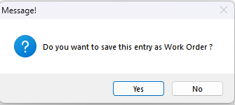
Figure 14. Save confirmation.
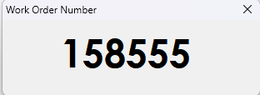
Figure 15. Recorded order number.
Do not retry blindly
If an error appears during save, record the exact message and order details. Search Recall before attempting another save, because the transaction may have failed before or after an order number was allocated.

6. Recall, update, convert, or cancel

6.1 Recall
- Open Recall and choose Work Order or Sales Quotation.
- Use the current-user view for your own orders, or All when your authorization permits it.
- Select the correct order number and verify the customer and line details.
The application retains a recall-ownership queue header for Work Orders and Sales Quotations, even when branch processing queue is disabled.

6.2 Update
- Recall the order before editing.
- Change the permitted customer, line, price, tax, comment, sales representative, or release information.
- Reconfirm every price invalidated by a customer change.
- Save and wait for the commit confirmation.
Concurrent update protection
Only one update or cancellation may hold the order lock at a time. If another user changed the order, recall the latest version and retry instead of repeating the previous edit.

6.3 Convert a quotation
Convert a Sales Quotation to a Work Order only after customer acceptance. The Work Order may reserve inventory and enter branch processing; the original quotation must not reserve inventory.

6.4 Cancel a Work Order
- Recall the correct Work Order and verify the customer, order number, and lines.
- Select Cancel and confirm the action.
- Wait for completion before leaving the screen.
A successful cancellation releases committed quantities, zeros order-entry quantities, closes the order, and closes related queue records in one local transaction.

7. Branch processing modes
Behavior | Direct-processing branch | Queue-enabled branch
Recall ownership header | Retained | Retained
Type-2 inventory commitment | Enabled under the current unified rule | Enabled
Queue items | Removed/not retained | Created and processed
Picker/prepared workflow | Not used | Used
Grouping | Disabled | Available only when enabled
For Invoicing | Hidden | Available only when enabled
Type-3 quotation commitment | Never | Never

7.1 Authorized Branch Functions
Authorized users can configure these settings under Settings > Branch Functions:
- Allow Branch Selection: shows the store database selector during the next startup.
- Assigned Database: locks the installation to the named RMS database when branch selection is disabled.
- Enable Branch Queue
- Allow order grouping
- Show For Invoicing button
- Show Import button
Branch-wide setting
Queue processing is a deployed branch choice, not an order-by-order choice. Changing it affects the application's workflow and requires branch-owner approval.

7.2 Configure branch selection
- Open the password-protected Settings form.
- Under Branch Functions, select Allow Branch Selection when an authorized operator must choose the store database during startup.
- To lock the installation, clear Allow Branch Selection and enter the Assigned Database, such as DVO_STORE_DB or GSC_STORE_DB.
- Select Save, close the application, and start it again.
Database protection
When branch selection is locked, startup compares the local RMS registry database with the Assigned Database. A mismatch stops the application before login.

Screenshot placeholder
Insert a screenshot of Settings > Branch Functions showing Allow Branch Selection and Assigned Database.

8. Queue processing and For Invoicing
- Save a type-2 Work Order at a queue-enabled branch.
- Assign the picker and pick location according to branch procedure.
- Enter prepared quantities and mark items prepared.
- Group only compatible customer Work Orders when grouping is enabled.
- Use For Invoicing only when the group is fully prepared.
- Complete the RMS transaction using the Work Order recall reference.
The configured RMS transaction-close trigger closes the corresponding queue when the completed transaction references the originating Work Order.

9. Draft recovery
Draft recovery protects unsaved entry work when the optional SOD_WO_DraftHeader and SOD_WO_DraftDetail tables are installed. Drafts are associated with the register and user.
- If the draft tables exist, follow the on-screen recovery prompt after login.
- Verify the recovered customer, order type, quantities, prices, taxes, and totals before saving.
- If the tables are missing, draft save and recovery are skipped; normal Work Order processing should continue.
- Only an authorized database administrator should deploy or repair draft tables.

10. Printing
Use Print after the order or quotation has been saved and assigned an order number.
- Select Order Number to print a saved Work Order or Sales Quotation.
- Enter the order number and select Print.
- The application reads the saved order type automatically: type 2 prints the Work Order heading and type 3 prints the Sales Quotation heading.
- Select Pick List only when a fulfillment pick list is required.
No manual template choice
Do not choose Work Order or Quotation manually. The same Order Number option prints the correct template from the saved order type. An unsupported order type is blocked instead of printing the wrong heading.

Screenshot placeholder
Insert a screenshot of the Print form showing Order Number and Pick List.

Before handing off a printout
Confirm the order number, customer, item codes, quantities, prices, tax, total, release type, and branch/database identity.

11. Keyboard shortcuts
Shortcut | Action
F2 | Run the item search using the current search text
F3 | Toggle barcode-search mode
F5 | Refresh the item list
F6 | Import, when the branch Import button is enabled
F7 | Select sales representative
F8 | Select customer
F9 | Cancel the current Work Order when permitted
F11 | Open Recall
F12 | Save the current Work Order or Sales Quotation

12. Troubleshooting
Message or symptom | Operator response
Branch Database Mismatch | Stop before login. Confirm the local RMS registry connection and the Assigned Database in the password-protected Settings form.
Cannot connect to the selected database | Verify branch network, server, database, and login details. Contact support if the database remains unavailable.
Username or password rejected | Confirm the selected database and re-enter your assigned credentials. Do not use another person's account.
Barcode returns no item | Refocus the search field, scan again, then search by item code or description. Report a missing barcode mapping.
Price displays as a dash | The customer was changed. Double-click each highlighted line and confirm its authorized price before saving.
Order type cannot be printed | The saved order is not type 2 or type 3. Record the order number and contact support; do not force a Work Order or Quotation heading.
Save is blocked | Check customer, sales representative, payment/release type, quantity, confirmed price, tax state, and required fields.
Order is locked by another user | Close the edit, recall the latest order, review changes, and retry.
Inventory adjustment would become negative | Stop the save and ask the inventory owner to validate current commitments and the order quantity.
Draft was not recovered | Continue only if the current order can be recreated safely; ask support to verify the optional draft tables.
For Invoicing is missing | The branch queue or button setting may be disabled. Confirm with an authorized branch administrator.
Possible duplicate after an error | Search Recall before creating another order. Escalate with the exact time, user, register, customer, and message.

13. Support and escalation
When reporting an issue, provide:
- Branch, workstation, server, and selected database
- Signed-in Work Order Entry username and register
- Order number, order type, and customer ID or company name
- Exact error message and the action immediately before it
- Whether the order can be found in Recall
- Screenshot with passwords and unrelated customer information removed
Contact | Details
SPU Development Team | systemdeveloper@starbright.com.ph
Database changes | Authorized branch/database administrator
Business-rule decisions | Branch operations owner

Never include
Database passwords, application passwords, full connection strings, or exported customer/order datasets in ordinary support messages.

Appendix A. Authorized deployment checklist
This appendix is for authorized branch and database administrators.
- Confirm and record BranchSelectionEnabled, ExpectedDatabaseName, QueueingEnabled, AllowOrderGrouping, ShowForInvoiceButton, and ShowImportButton.
- Back up and verify the target RMS database.
- Run Ensure_Queueing_Compatibility_Tables.sql where required.
- Run Ensure_Work_Order_Draft_Tables.sql only when draft recovery is approved.
- Verify the deployed SOD_sp_InsertQoute and SOD_sp_InsertQouteEntry behavior for Work Orders and Sales Quotations.
- Confirm that RMS reason code 701, type 6, exists exactly once. The application resolves its branch-specific database ID during save and recall.
- Validate fractional quantities in RMS functions, reports, and queue prepared-quantity fields.
- Remove plaintext credentials from deployment files and rotate credentials previously stored in source.
- Run create, recall, update, cancel, quotation, queue, and rollback tests against a non-production database.
- Reconcile open Work Orders, Queueing rows, and Item.QuantityCommitted before production rollout.

Appendix B. Current operational limitations
- The executable retains the historical filename Work Order Entry_V4 even though this is guide version 6.
- The application is a Standard EXE and writes directly to RMS tables and procedures rather than using the POS QSRules transaction workflow.
- Manual tax exemption requires exactly one RMS reason-code record with code 701 and type 6 in each branch database.
- Legacy queue prepared quantity is integer-based.
- Twenty-one database-free unit tests cover price rules, branch validation, print-template selection, senior-citizen tags, and tax calculations. Branch integration testing is still required.
- Existing screenshots are interface references and may differ slightly according to branch settings and screen resolution.

